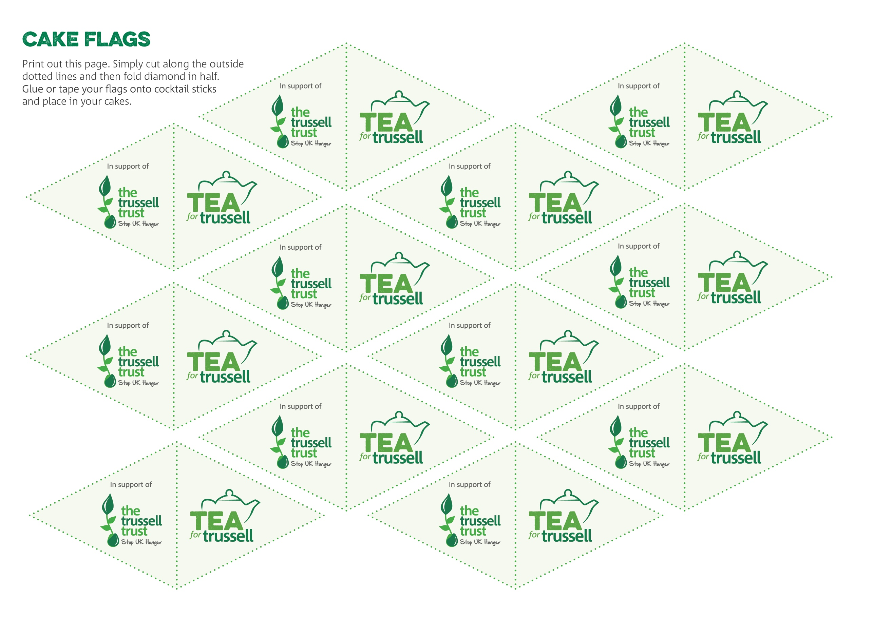

Stoke-on-Trent Foodbank is Reg. Charity in England  
& Wales & Scotland (**1150820**).