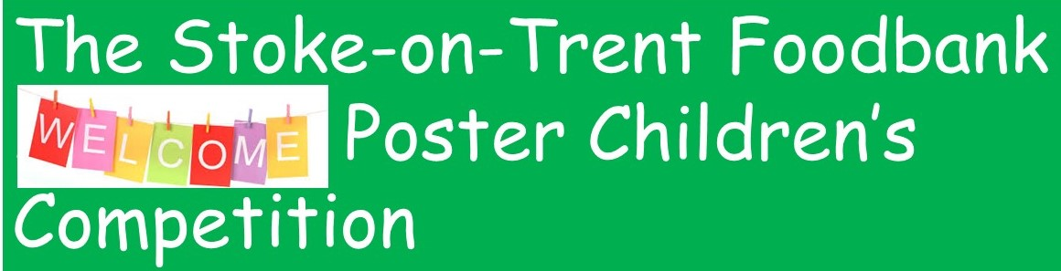We are looking for a winning poster design to use for our 16 centres to show the warm welcome and helping hand that people, who are our guests, receive.
The winner will be chosen by our Trustees and Young Ambassadors and will receive a laminated poster of their design and a Gift Voucher to spend.
This Stoke-on-Trent Foodbank Welcome Poster Children’s Competition is for children and young people education year’s 1 to 13;
To do a picture for our centre Welcome posters, up to A4 in size – different art materials can be used or a computer produced image, as long as you can send us a clear image to print (see below)
See our website https://stokeontrent.foodbank.org.uk/ and picture resources; https//………………….
ENTRIES ONLINE ONLY
Please scan in the images or wording or take a clear photo to be emailed. (The original artwork needs to be made available for use by Stoke-on-Trent Foodbank staff, if required).
(picture scans preferably to 600 dpi quality)

Also, for each entry please complete the following, scan or photograph and email together to;
caroline@stokeontrent.foodbank.org.uk (questions here also) CLOSING DATE: 1st July 2021
ENTRY FORM:
Child/ Young person’s name: ………………………………………………………………………………………………………………… Age: ……
School or organization if applicable: …………………………………………………………………………………………………………………………………………………………………………
Adult contact name & email: …………………………………………………………………………………………………………………………………
Parental / guardian consent is required below. This consent covers a) sending the design for consideration in the competition b) if the design wins and is chosen, permission to use it c) will make available the original design to Stoke-on-Trent Foodbank staff, if required to assist with reproducing it d) use of the winners’ first name, age (and organization) on Stoke-on-Trent Foodbank social media and the poster.
Consent given by ……….………………………………………………………. Signature ………………………………………………….
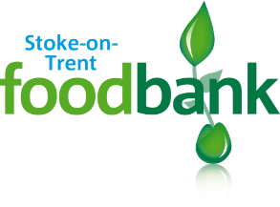

Reg. Charity No. 1150820

