MARCH 2021 – STOKE-ON-TRENT FOODBANK, INFORMATION SHEET.
SoT Foodbank have been operating locally since 2012, when the level of child food poverty was recorded at 29%. The usage levels have increased year on year with child poverty now at 42%.
Founded by the Trussell Trust, we are part of their national network guided by their operating standards and principles. SoT Foodbank is also registered as an independent charity and business for governance and operations. We play an active role in the network as one of their Pathfinder foodbanks, sharing best practice and inputting statistics, working towards the longer term aim of removing the need for foodbanks.
Our 16 centres church-based centres, manned by 200 plus volunteers operate a rotating basis so that emergency food parcels are available six-days a week, across the city of Stoke-on-Trent and outlying areas. (From as far North as Biddulph and out to Meir in the South East). We could not do what we do without the dedicated support of our volunteers and community (individuals, families, church and other community groups and businesses) that generously donate so that local people meet the needs of other locals who are struggling.
People come to us who’ve been identified as in emergency food crisis by a professional, our wide network of 400 referral agencies include; children’s centres, health centres and Citizen’s Advice.
Issued with a food voucher this is exchanged for 3 days of nutritionally balanced food to feed the person and their household.
In addition we work with Money Matters and other charities and organisations sign-posting our guests to where they can get advice to tackle the root cause of the crisis that brought them to us.
The 2019-Covid pandemic exasperated the existing causes of food poverty; low income, benefit changes and delays, and illness. The social and economic impact in 2020 saw job losses, reduced and uncertain waged hours, delays with new benefit claims. In 2021 this is continuing with long term furloughed staff now experiencing redundancy and self-employed businesses folding. Over 68,000 people locally are over-indebted, ie cannot pay current bills.
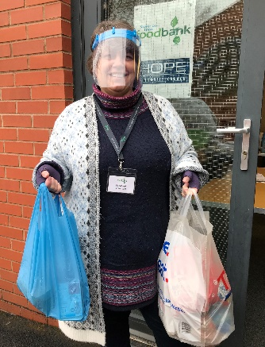
Thanks to the dedication and determination of our centre volunteers and staff, and continued generous public donation, we were able to quickly adapt to Covid-19 safe working practices and, with many frontline referral services no longer working face to face, we extended our staffing capacity to assist people in food crisis. We have moved from paper vouchers to e-vouchers and follow on signposting has continued with leaflets and by telephone conversation.
In 2020 we fed 14,000 people, 1552 in December alone, over a third of whom were children.
In 2021 we are continuing to work strategically in partnership with a variety of local stakeholders, in order to reduce the need for emergency food in our community, and input statistics and other evidence through the Trussell Trust to influence government policy, to make changes to create a system where no one is left behind.
As one of 19 foodbanks selected by the Trussell Trust to be part of their national consultation Pathfinder Programme to share best practice and support the wider network to ensure that this happens.
We are a small charity but part of a wider network, we can work closely with match up our activities evolving opportunities to businesses’ social responsibility needs and wants. For example; https://stokeontrent.foodbank.org.uk/2020/12/03/locally-based-company-steps-up-to-provide-christmas-dinners-for-local-people-in-need/
These include food collections and donations, financial giving and fundraising. We also have employee volunteering opportunities, including charity days. We also work in partnership on media (newspaper and radio) and social media (Facebook, Twitter and Instagram) news releases.
March 2021 we will be releasing our 21 for 2021 Appeal. This has been triggered by the amazing support we received from businesses who stepped up in 2020 looking to give back to the local community in these challenging times.
Please see our website and social media:

For enquiries please contact Caroline

Community and Business Liaison Co-ordinator
mobile: 07946 243861
email: caroline@stokeontrent.foodbank.org.uk

