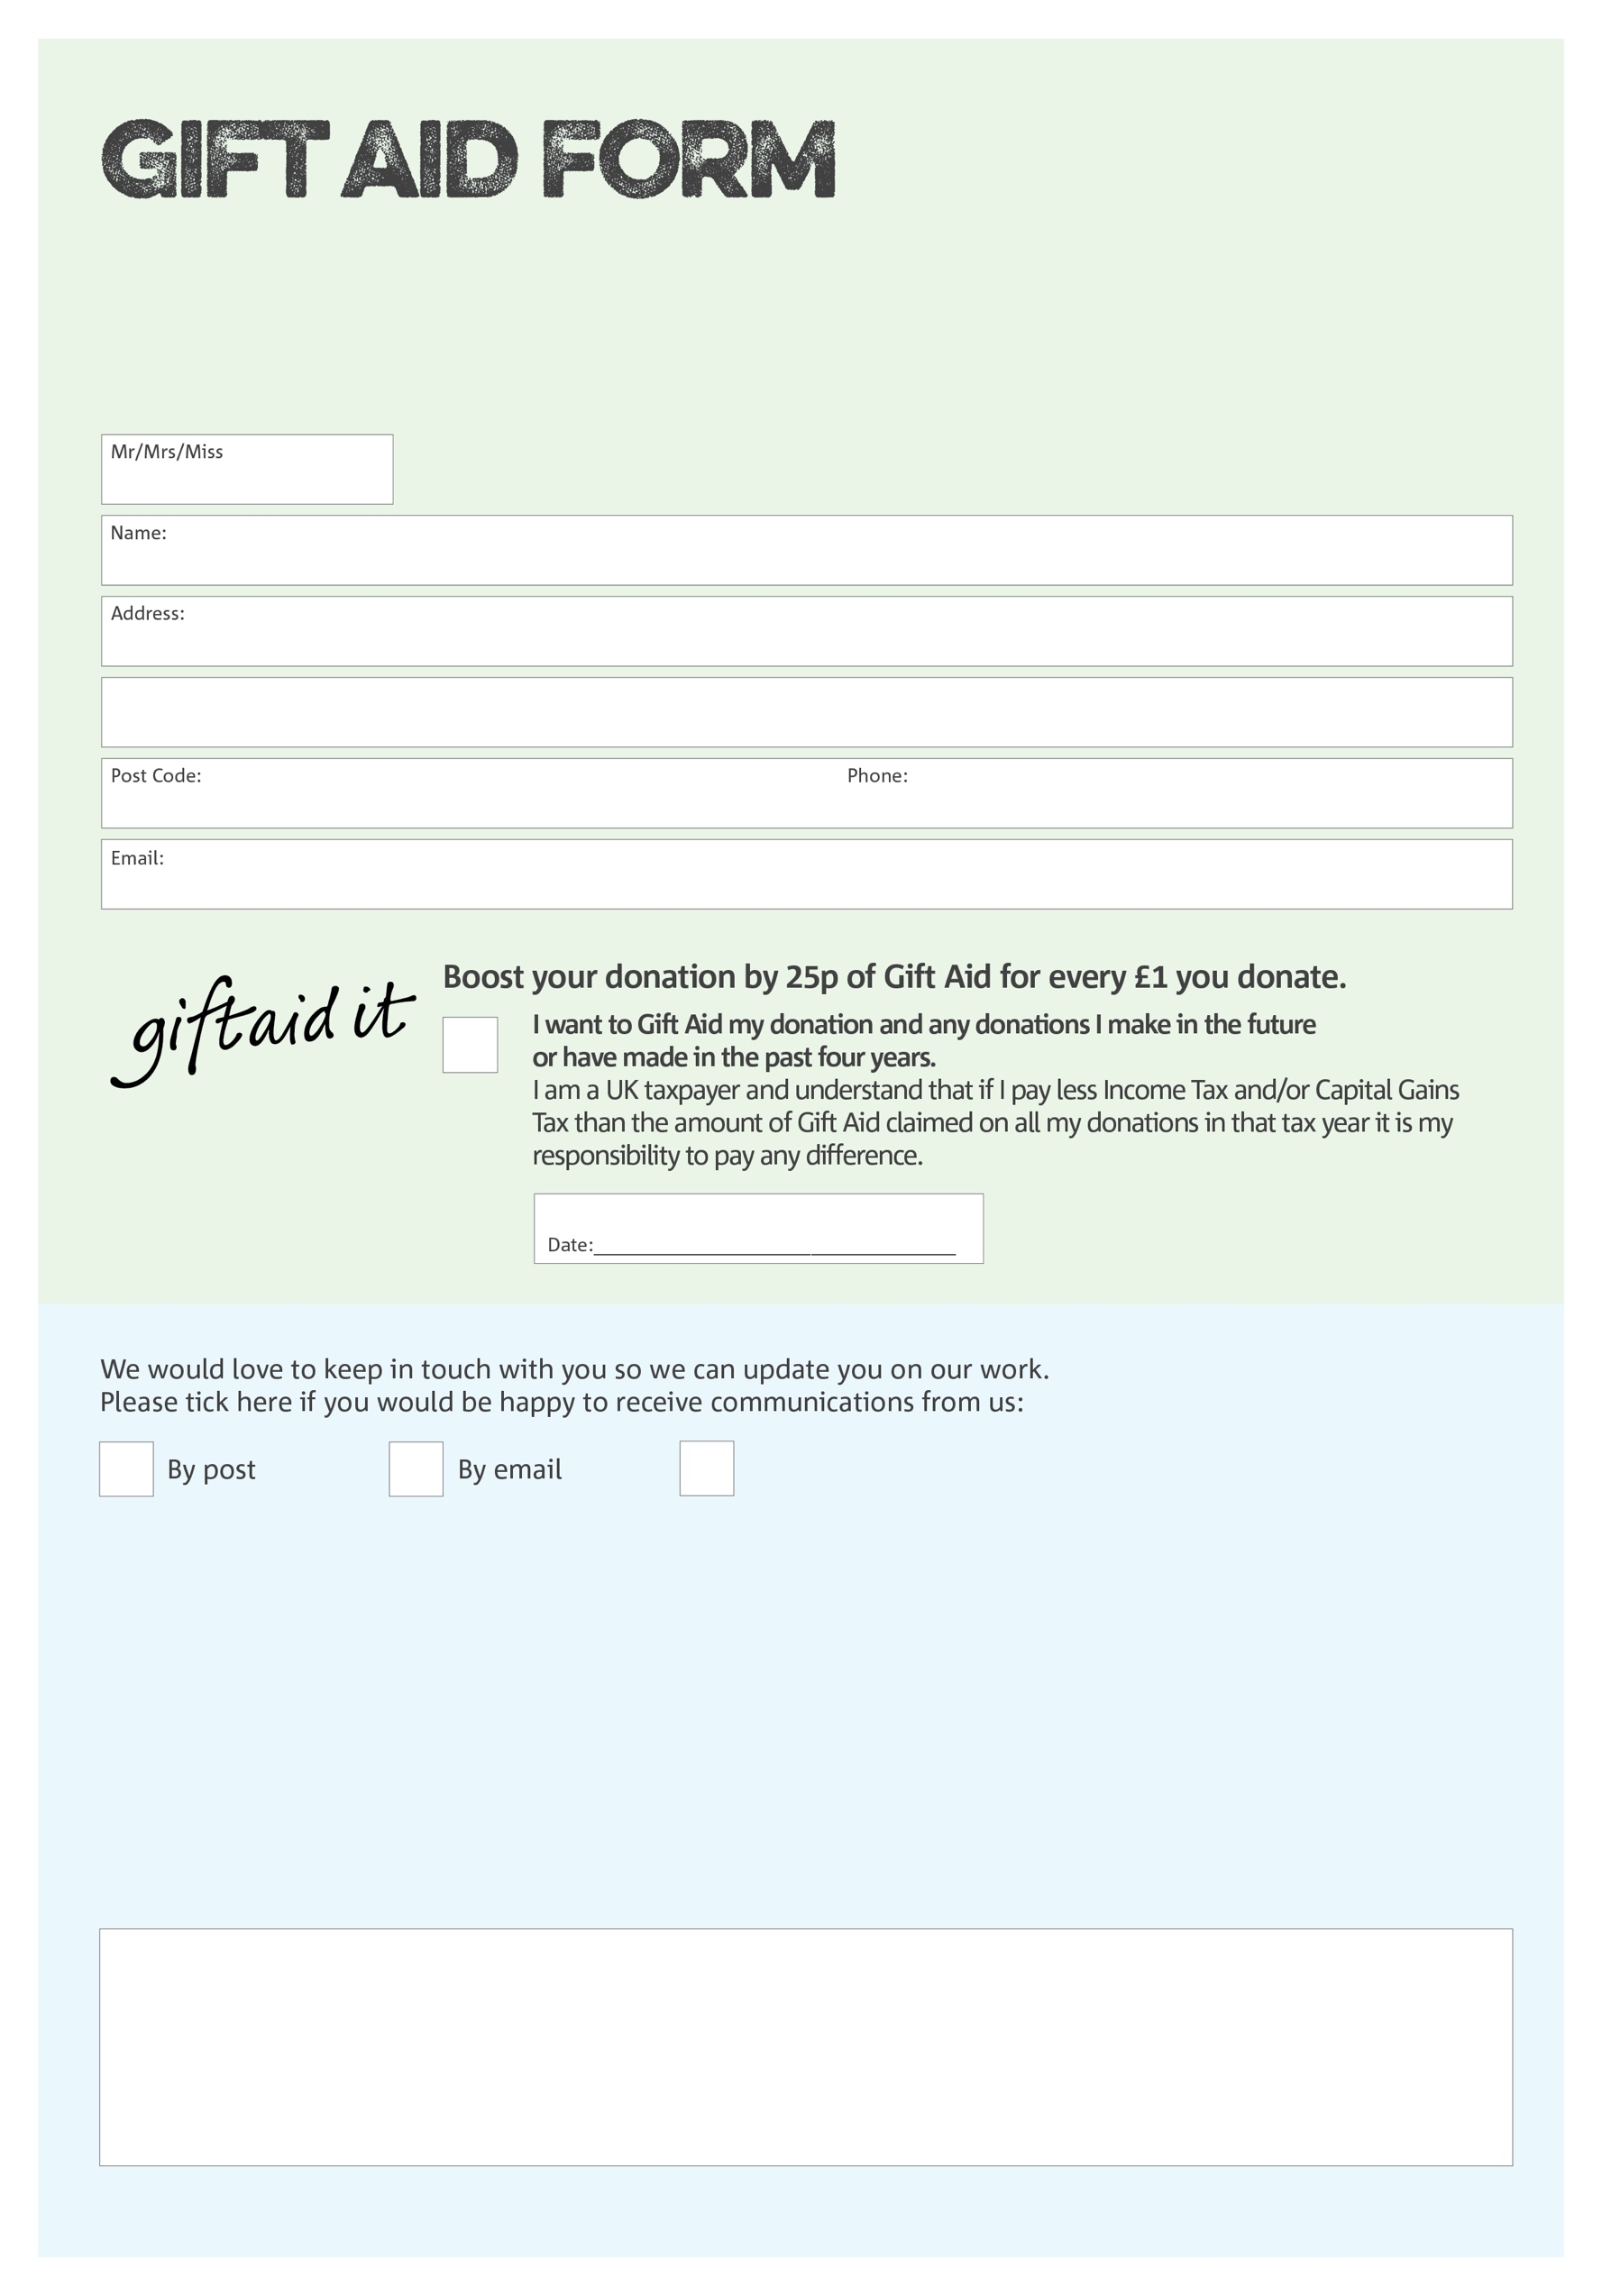

By filling in this form Stoke-on-Trent Foodbank will receive an extra 25p for every £1 you give at no extra cost to you. Thank you!

You can change your preferences any time by contacting us on 07496564436 or emailing us at

info@stokeontrent.foodbank.org.uk

I do not wish to receive future communications from XXXX Foodbank

**Data protection**

Stoke-on-Trent Foodbank is committed to protecting your privacy and will process your personal data in accordance with the Data Protection Act 1998. Stoke-on-Trent Foodbank collects information to keep in touch with you and supply you with information relating to our work. Stoke-on-Trent Foodbank will never sell or pass your details to anyone who isn’t directly working on our behalf.

We would love to know why you have chosen to donate to Stoke-on-Trent Foodbank. If you would like to share your motivation let us know below:

Charity Number 1150820. Registered in England & Wales