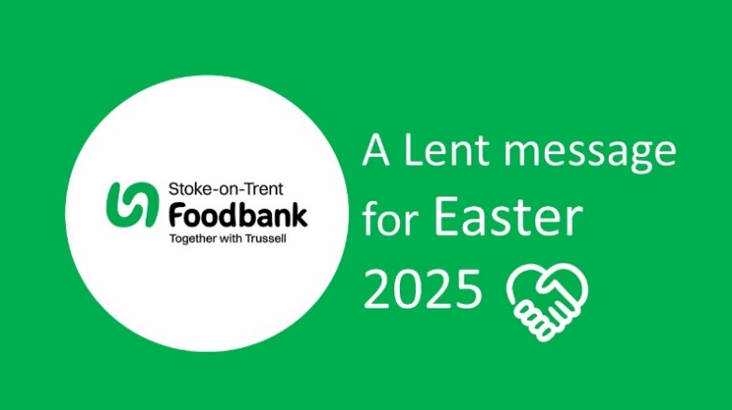  From our Director of Services, Corrine Boden MBE:  “ Our foundation is built on a four-letter word…LOVE  It is written in our constituition and beyond.  It is an unbroken thread that forms the fabric of what we do, and what we deliver!  We have seen many people from different sectors of the community come together to support one another.  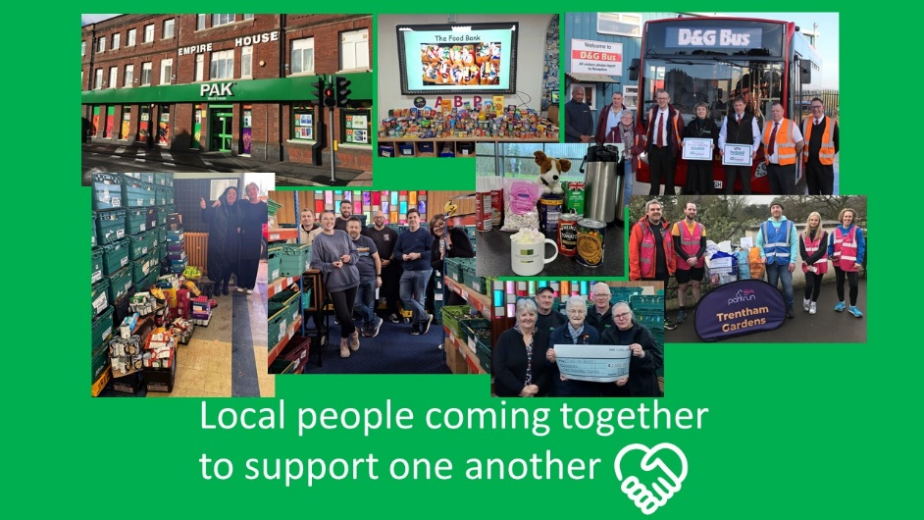  ‘ The underlying truth is that people are driven by love.’  Marcus Buckingham  Co-head of ADP Research Institute, where research is carried out around the world on all aspects of human thriving. | We are in a trustless world, people need ‘Hope’, faith, love and trust.  The Bible tells us in Corinthians that we are nothing without LOVE!  ‘ …Trust steadily in God, hope unswervingly, love extravagantly.  And the best of the three is love. ’ Corinthians 13, v13  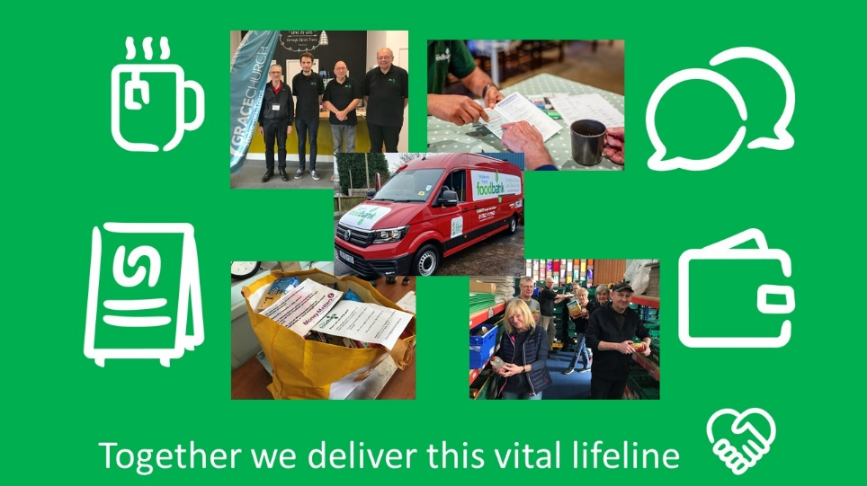  Please help us to continue to share this outpouring of love across our local communities this Easter…”  Our EASTER 2025 VIDEO & RESOURCES can be found on our website at:  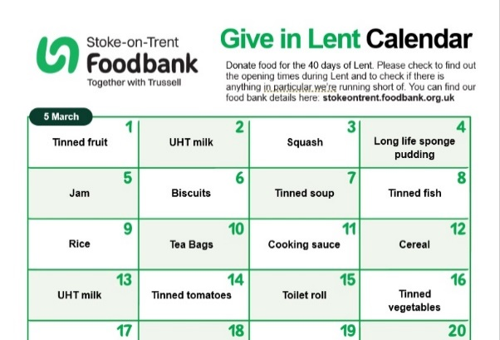  https://stokeontrent.foodbank.org.uk/news  This includes an AdLent Calendar for food.

