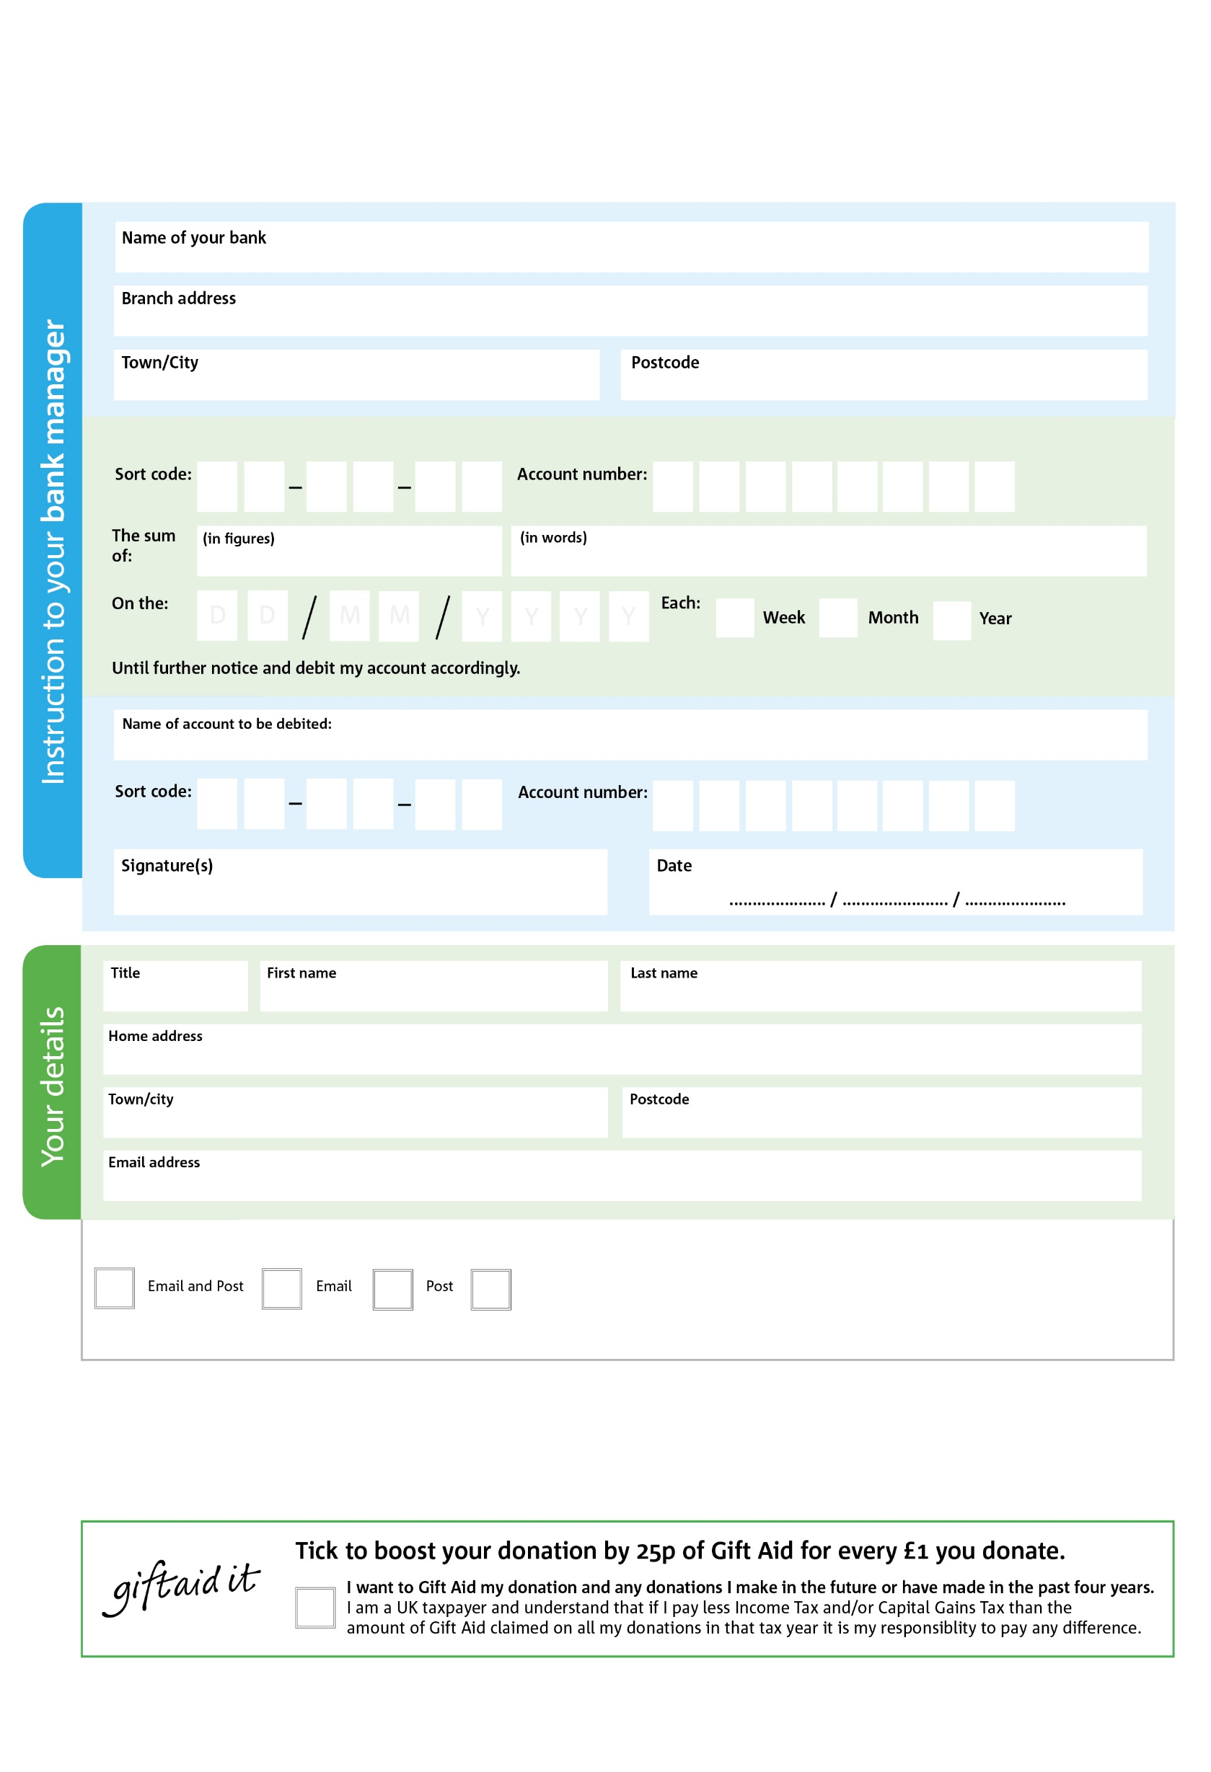

POSTAL ADDRESS: Stoke-on-Trent Foodbank,Hanley Fire Station, Lower Bethesda Street, Hanley, Stoke-on-Trent, ST6 2JJ

**Standing Order Mandate**

**www.stokeontrent.foodbank.org.uk**

**Please pass this form onto the foodbank, using the foodbank’s address at the bottom, who will save a copy for their records. They will then send it onto your named bank or building society.**

X

V

X

V

X

V

X

V

X

V

X

V

X

V

X

V

X

X

X

X

X

X

We would love to keep you up to date with information about Stoke-on-Trent Foodbank. Please tick your preference:

You can change your preferences any time by contacting us on 07496564436 or emailing us at info@stokeontrent.foodbank.org.uk

I do not wish to receive future communications from Stoke-on-Trent Foodbank

Please pay Stoke-on-Trent Foodbank,

**Data protection**

Stoke-on-Trent Foodbank is committed to protecting your privacy and will process your personal data in accordance with the Data Protection Act 1998. Stoke-on-Trent Foodbank collects information to keep in touch with you and supply you with information relating to our work. Stoke-on-Trent Foodbank will never sell or pass your details to anyone who isn’t directly working on our behalf.

Reg. Charity No: 1150820 | Reg. in England & Wales

You can change your preferences any time by contacting us on XXXXXXXXXXX or emailing us at XXXX@XXXXXXXXXX.foodbank.org.uk

I do not wish to receive future communications from XXXXXX Foodbank